Attention Haitians!

Are you interested in Temporary Protected Status (TPS), allowing you to live and work legally in the U.S.?

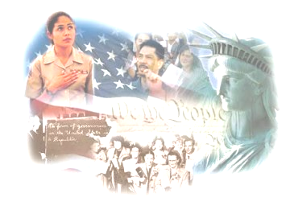
Come to TPS DAY!

February 17, 2010
9:00 am to 4:00 pm
At Shalom Community Church
900 NE 132nd Street, Miami FL

Sponsored by:
Church World Service

We are fully qualified to practice immigration law, and our services are free or low cost! For more information and to register for TPS Day, contact us at:

(305) 774-6770 ext. 139, 141 and 154

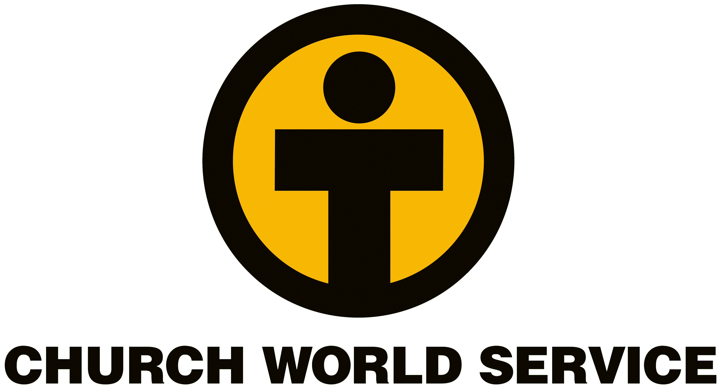

Seek qualified legal counsel, as there are important filing deadlines and eligibility requirements for TPS. For example, you must have resided in the United States since at least January 12, 2010.

