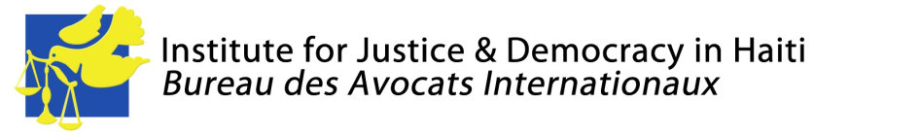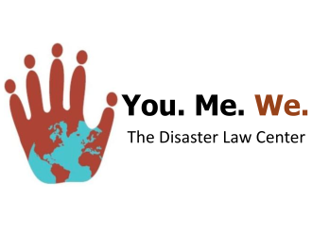

CONTACT:
Mario Joseph, Bureau des Avocats Internationaux, mario@ijdh.org, 011 (509) 3701 9879 (Haiti)
Nicole Phillips, Institute for Justice & Democracy in Haiti, nicole@ijdh.org, 001 (510) 715-2855
Alison Roh Park, Center for Constitutional Rights, apark@ccrjustice.org, 001 (212) 614-6480
Nora Rasman, TransAfrica Forum, nrasman@transafricaforum.org, 001 (202) 553-7186
David Lerner, Riptide Communications, 001 (212) 260-5000

Haiti Government Continues Evicting Earthquake Survivors from Displaced Persons’ Camps despite Human Rights Commission Orders

Amid Warning Signs in New Presidency, Rights Groups Intensify Efforts to Enforce Government Compliance, Protect Victims with New Request

June 15, 2011, Washington D.C. – Today, the Center for Constitutional Rights (CCR), Institute for Justice & Democracy in Haiti (IJDH), Bureau des Avocats Internationaux (BAI), You.Me.We., and TransAfrica Forum jointly filed a request to the Inter-American Commission on Human Rights (IACHR) to take further action on the increasingly urgent issue of forced evictions taking place in Haiti’s displacement camps housing hundreds of thousands of earthquake survivors.

The rights groups’ request follows up on the precautionary measures issued by the IACHR to the Government of Haiti in November 2010 calling for a moratorium on evictions in displacement camps, among other measures to protect those rendered homeless by the January 12, 2010 earthquake. The groups’ original request, filed on behalf of victims from five displacement camps, came amidst widespread evidence of government brutality, threats and coercion that accompanied forced evictions of the makeshift settlements of displaced persons.

Forced evictions in camps – often carried out by state agents – have risen in the seven months since the measures were to be implemented, and the situation has grown even more urgent since Haiti’s new President Michel “Sweet Micky” Martelly took office in May. Martelly has faced criticism for his pledge to close all camps within six months without providing a concrete plan for re-housing those currently living in camps. In his first few weeks in office, government officials have already unlawfully closed at least three camps, forcing 1,000 residents out of their provisional shelter without providing them with any alternative housing. On May 19th, President Martelly announced to a settlement of 100,000 residents on the outskirts of Port-au-Prince that they would be evicted in the coming weeks in order to make room for a factory. He made no mention of alternative housing.

The Haitian government’s failure to comply with the original precautionary measures and the new government’s continuation of inhumane and illegal practices prompted the rights groups to file for an update to the original measures. “The Haitian government has an obligation to implement the Commission’s directives,” explained Mario Joseph, Managing Attorney of Bureau des Avocats Internationaux. “The failure to do so demonstrates the government’s disregard for its obligations under international law.”

The update includes the original measures, which called for a moratorium on all evictions – lawful and unlawful – until a comprehensive housing policy is implemented. It also calls for new directives, such as training for government officials on the illegality of forced evictions and their responsibility to protect internally displaced persons, along with eight other recommendations.

Vince Warren, Executive Director of the Center for Constitutional Rights, stated, “Internally Displaced Persons have the right to live in the camps while a comprehensive housing plan is put into practice. We are talking about a population that has no-where else to go. The evictions taking place are illegal under both Haitian law and international law, and we hope the Inter-American Commission on Human Rights will intervene and urge this new government of Haiti to enact a moratorium on evictions immediately.”

The update also requests the IACHR to urge the government to build the capacity of its public housing agency to ensure the needs of its displaced population are met. “The Haitian government can best protect displaced persons from forced evictions by facilitating their access to adequate and affordable housing,” said BAI attorney Jeena Shah.

Nicole Lee, President of TransAfrica Forum, stated, “Eighteen months later, people remain in camps because they still have no other options. These most recent forced evictions remind us of the need for a comprehensive housing strategy that involves Haitian civil society organizations and includes safe and secure long-term housing, job opportunities, access to markets and infrastructure development.”

The groups also point out the role that the U.S. administration can play to help Haiti avoid evictions. “The U.S. has disbursed about a quarter of the funds pledged to rebuild Haiti,” said Nicole Phillips, Staff Attorney at the Institute for Justice & Democracy in Haiti. “We must make good on our financial commitment so that reconstruction can begin and Haitians can have a place to live besides dilapidated camps. We must also ensure that the assistance we do provide does not support forced evictions or other harassment of displaced people.”

The filing can be seen in its entirety here: http://ijdh.org/archives/19215.

The Center for Constitutional Rights is dedicated to advancing and protecting the rights guaranteed by the United States Constitution and the Universal Declaration of Human Rights. Founded in 1966 by attorneys who represented civil rights movements in the South, CCR is a non-profit legal and educational organization committed to the creative use of law as a positive force for social change.

Founded in 1995, the Bureau des Avocats Internationaux (BAI) is the only public interest law firm in Haiti. With the support of the Institute for Justice & Democracy in Haiti, the BAI uses litigation, advocacy, documentation and grassroots empowerment to advance the rule of law and challenge the unjust structures that violate the human rights of Haiti’s poor majority. Visit HaitiJustice.org. Follow @IJDH.
Founded in 1977, TransAfrica Forum is the oldest and largest African American human rights and social justice advocacy organization promoting diversity and equity in the foreign policy arena and justice for the African World. TransAfrica works with human rights, labor and women’s organizations in Haiti to ensure more just and equitable U.S. foreign policy towards all Haitians.
You.Me.We is disaster relief organization that defends human rights in the aftermath of sudden on-set disasters.

