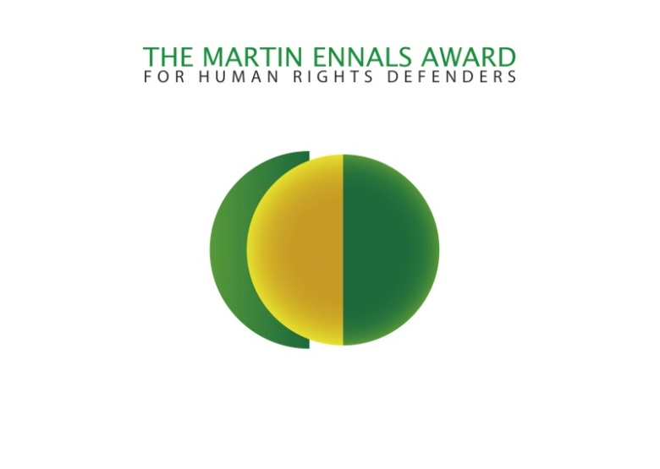
Summary of the Martin Ennals Award
The Martin Ennals Award is given annually to a Human Rights Defender for their work defending the rights of others. A new format in 2012 includes three Final Nominees announced in April followed by selection of the Laureate in October.
Credibility of the Award:
- The Award is selected by an independent jury of ten organizations (see List Below)
- The City of Geneva is committed to supporting the city as the “World Capital of Human Rights” and chose the Martin Ennals Award as a key element of their strategy. Their support includes a city-wide poster campaign.
- The High Commissioner for Human Rights, or Deputy, has presented the award over the last years, which adds to the gravitas of the award.
- Micheline Calmy-Rey joined as Chair of the Foundation in 2012.
Benefits of being a Laureate/Final Nominee:
- Protective publicity: This has been repeatedly acknowledged by Laureates as having real value.
- Recognition: The ceremony in Geneva is an important platform for all three nominees who have a chance to address an audience of 700+ interested persons. The European Union Representative in the Laureate’s country also holds a diplomatic reception for the winner.
- Advocacy: This award opens doors to high-level discussions on the concerned Human Rights issues. Previous Laureates have said it raises the quality of the dialogue.
- Financial: the Laureate gets 20 000 CHF, while all three nominees get 11 500 CHF from the City of Geneva for a Human Rights project, along with a travel grant.
- Film portrait: We commission short films (7 Min.) on our nominees which can be seen on our website. Footage can also be made available.
Martin Ennals Award Jury

- Amnesty International,
- Human Rights Watch,
- Human Rights First,
- Int’l Federation for Human Rights,
- World Organisation Against Torture,
- Front Line Defenders,
- International Commission of Jurists,
- German Diakonie,
- International Service for Human Rights
- HURIDOCS

