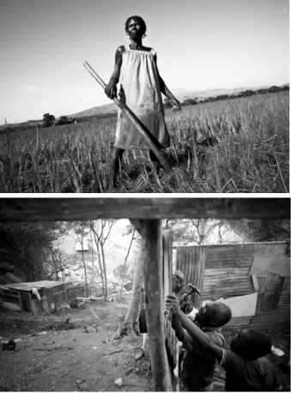
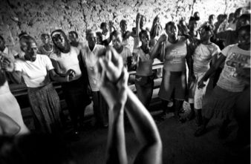
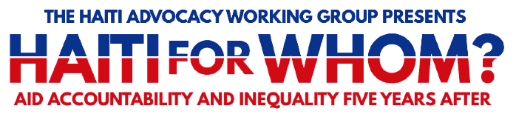
Aid Accountability in Haiti -Following Haiti's devastating 2010 earthquake, the international community announced approximately $10 billion in relief and reconstruction assistance. With limited tangible results on the ground, Haitian and U.S. civil society groups have been asking "where has the money gone?", prompting the U.S. Congress to pass the 2014 Assessing Progress in Haiti Act last year. This panel will look at how U.S. and other foreign assistance funding has been spent over the last five years and discuss improving transparency and accountability around the aid efforts of both Haitian and international entities.

Wednesday, March 4, 2015
421 Cannon House

Friday, March 6, 2016
2168 Rayburn House, Gold Room

The Haiti Advocacy Working Group (HAWG) is a working group of international development, faith based, human rights and
social justice organizations advocating on
issues related to US-Haiti policy.
For more information, contact Jasmine Huggins,
jhuggins@cwsglobal.org or Charissa Zehr, charissazehr@mcc.org

Panelists: Prospery Raymond, Country Manager for Haiti and the Dominican Republic, Christian Aid; Prospere Charles, Social Scientist, former Haiti Representative for Project HOPE; Jake Johnston, Research Associate, Center for Economic and Policy Research; Moderator: Jasmine Huggins, Sr. Policy and Advocacy Officer for Haiti, Church World Service

Food Insecurity, Climate and Hunger in Haiti -Over half of the Haitian population is food insecure. Some parts of the country, notably the far west, are particularly vulnerable. In addition to earthquakes, Haiti is directly hit by hurricanes and storms, many of which cause extensive damage. The country has also experienced severe droughts in recent years, along with changing rainfall patterns that affect food production. With only 2% forest cover, Haiti is vulnerable to erosion, landslides, and flooding. Food insecurity for vulnerable groups increased significantly after the earthquake, notably among women and girls. This panel will explore why food insecurity exists in Haiti, how climate change exacerbates it and what the direct impact of this situation is on key vulnerable groups. It will also make key recommendations for policy and programs to address the situation.

Panelists: Prospery Raymond, Country Manager for Haiti and the Dominican Republic, Christian Aid; Cher Frere, Senior Program Officer SKDE; Marie Ange Noel Activist - Femmes Decide; Moderator: Marc Cohen OXFAM

Democracy and the Political Situation in Haiti - For decades, Haiti's institutions and economic development have been undermined by political crises and outside intervention. The last five years have only confirmed this pattern: Haiti's November 2010 elections were tainted by irregularities and foreign interference, the subsequent legislative elections have been delayed over three years and recent protests led to the resignation of Prime Minister Laurent Lamothe. This panel of Haitian and U.S. experts will examine the causes of recent political instability and discuss how to ensure that Haiti's next elections help strengthen rather than weaken democratic rule.

Panelists: Ginette Cherubin, architect and urban planner; former member of Haiti's Provisional Electoral Council (2007-2011); former Minister of Women's Issues (1996-1997); Mario Joseph, Managing Attorney, Bureau des Avocats Internationaux (Haiti); Nixon Boumba, in-country (Haiti) consultant to American Jewish World Service; Brian Concannon, Executive Director, Institute for Justice and Democracy in Haiti; Moderator: Alexander Main, Senior Associate for International Policy, Center for Economic and Policy Research (CEPR)

Economic Growth: Jobs or Sustainable Livelihoods? -This panel will look at how the proposed economic development strategies for Haiti (Industrial parks like Caracol, mining & extractives, tourism projects) can share the economic benefits among more people. How can we ensure that workers are earning a living wage? What are the impacts of this development on marginalized groups? Why aren't more benefits going to Haitians? The discussion will focus on creating sustainable livelihoods for more Haitians.

Panelists: Nixon Boumba - in country (Haiti) Consultant to American Jewish World Service Lauren Stewart, Solidarity Center, Kysseline Cherestal, Action Aid ; Moderator - Elaine Zuckerman - Gender Action

Looking back and looking forward- In this interactive panel, Haitian partners will give personal and professional testimony of their experiences of working in their sectors in the last five years since the earthquake, and make policy recommendations for the next five years. A panel of experts will put questions to them directly and also take questions from members of the audience.

Speakers: Cher Frere ,Marie Ange, Mario Joseph, Ginette Cherubin, Nixon Boumba, Prospery Raymond, Rony Janvier; Moderator: Kysseline Cherestal - Action Aid

A Prolonged Epidemic: How Cholera Got to Haiti & How It Can Be Addressed - Cholera came to Haiti in 2010 with the arrival of UN peacekeepers at the MINUSTAH base in Mirebalais, Haiti. Raw, infected sewage from the base leaked into Haiti's largest river system, and a deadly outbreak continues to plague Haiti. To date, over 8,800 people have died and more than 725,000 have been infected. These numbers regularly increase. This panel will provide an in-depth analysis of how cholera has persisted, its legal and public health implications, and recommendations for eradicating it.

Panelists: Muneer Ahmad, Esq., Yale Law School; Dr. Louise Ivers, Partners in Health; Mario Joseph Av., Bureau des Avocats Internationaux; Moderator: Brian Concannon, Esq., Institute for Justice & Democracy in Haiti

