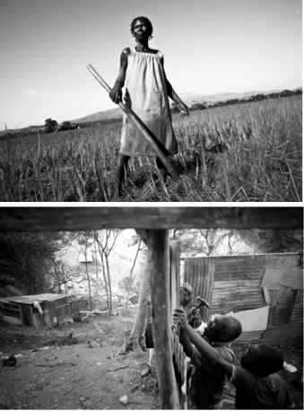
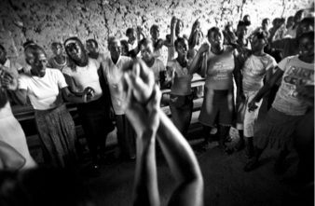
Wednesday, March 4, 2015
421 Cannon House Office

Friday, March 6, 2015
2168 Rayburn House Office, Gold Room

The Haiti Advocacy Working Group (HAWG) is a working group of international development, faith based, human rights and social justice organizations advocating on issues related to US-Haiti policy.

Speakers (continued)

Marc Cohen is Senior Researcher at Oxfam America in Washington, DC. His research currently focuses on humanitarian policy and climate change. He has carried out research in Haiti since 2007 on such topics as social policy; agricultural development; water, sanitation, and hygiene policy; post-earthquake urban recovery; and climate change adaptation. Cohen received his Ph.D. in political science from the University of Wisconsin-Madison.

Brian Concannon Jr., human rights lawyer and activist, directs the Boston-based Institute for Justice & Democracy in Haiti (IJDH), which helps Haitians enforce the human rights they need to escape poverty and vulnerability. IJDH litigates cases in Haitian, U.S. and international courts.

Jasmine Huggins is Senior Policy and Advocacy Officer at Church World Service, focusing on aid accountability, housing, child protection, statelessness, aid accountability and climate change. She has previously worked in program management and advocacy for Christian Aid in London and has a Masters degree in Social Sciences.

Marie Ange Noel is an activist, trainer, grassroots mobilizer, motivator from Jacmel, Haiti. She has trained Haitian producers in agricultural technology, organized youth activists in church and popular movements, promoted and organized women for participation in political life, served as President of the Electoral Office of The Valley of Jacmel. She is Co-founder and Coordinator of Fanm Deside, which advocates for the socio-economic empowerment of women and against gender-based violence.

Lauren Stewart is the Senior Program Officer for Haiti and the Dominican Republic at the Solidarity Center, AFL-CIO, which empowers workers to earn safe and dignified livlihoods. Her Haiti work focuses on labor rights education, union organizing in the garment sector and advocacy for decent employment. Her 2014 study entitled, The High Cost of Low Wages, examines the cost of living compared to the inadequate minimum wage in the Haitian garment industry. Ms. Stewart studied International Politics at Pennsylvania State University.

Elaine Zuckerman is President and Founder of Gender Action, the only organization dedicated to promoting gender equality and women’s rights in all International Financial Institution (IFI) investments. She was country officer for Haiti at the Inter-American Development Bank (IDB). She is on the Board of Directors of the National Council of Women’s Organizations, Promundo and Caring Economy Campaign Advisory Council.

Alexander Main is the Senior Associate for International Policy, Center for Economic and Policy Research (CEPR) in Washington, DC. His work focuses on U.S. foreign policy toward Latin America and the Caribbean and engages with U.S. policy makers and civil society groups.He holds degrees in history and political science from the Sorbonne University in Paris, France

Ginette Cherubin is an architect and poet based in Port-au-Prince. She was Minister of Women's Affairs from 1996 to 1997 and was a member of two of Haiti's Provisional Electoral Councils (CEP) between 2007 and 2011. She has written a book about her experience at the CEP entitled "Le Ventre pourri de la bete" (The Rotten Belly of the Beast), published in 2013 by the State University of Haiti.

Muneer Ahmad is a Clinical Professor of Law and Supervising Attorney at Yale Law School, where he co-teaches in the Transnational Development Clinic and the Worker and Immigrant Rights Advocacy Clinic (WIRAC). His scholarship examines the intersections of immigration, race, and citizenship in legal theory and practice.

Nixon Boumba joined AJWS in July 2012. A well- known and respected activist in Haiti’s social movement, and active member of the Popular Movement for Democracy (MODEP), Boumba supports Haitian grassroots groups in working together toward common goals, especially regarding economic, social and cultural rights for the Haitian majority, including the fight against land grabbing and mining.

Dr.Prospere Charles, serves as Haiti’s representative for Project HOPE, a leading global health non-profit organization. He oversaw the team for construction and operations of the first physical rehabilitation center in Haiti. He successfully managed distribution of $160 million in medical supplies and disaster relief.

Kysseline Jean-Mary Chérestal is a Senior Policy Analyst at ActionAid USA, focusing on advocacy and campaigning for land tenure security for smallholder farmers, particularly women, in developing countries. Kysseline received her Juris Doctor from Fordham Law School.

Fortuné Cher Frère has experience as assistant coordinator with
Productivity of Cooperatives of Haiti (PCH). Since 2004, he has been a field coordinator with the Christian Center for Integrated Development (SKDE), working on community development with 12 agricultural cooperatives in the Northwest and Artibonite departments. He has studied economics and sociology, focusing on management of cooperatives.

Dr. Louise Ivers, a medical doctor, and Senior Health and Policy Advisor for Partners In Health (PIH). She is Associate Professor of Global Health and Social Medicine and Associate Professor of Medicine at Harvard Medical School in Boston. Based in Haiti from 2003-2012, she led PIH’s response to the 2010 earthquake and the ongoing cholera epidemic.

Rony Janvier is Program Officer for Church World Service in Haiti. An accountant by training and student of theology, he accompanies partners and programs in food security, child protection, programs for disabled people, and housing.
Jake Johnston is a Research Associate at the Center for Economic and Policy Research (CEPR) in Washington D.C. He is the lead author for CEPR’s Haiti: Relief and Reconstruction Watch blog and has authored papers on Haiti concerning the ongoing cholera epidemic, aid accountability and transparency and the U.S. foreign aid system.
Wednesday, March 4
421 Cannon House Office Building
8:30am Coffee served

9:00 - Aid and Accountability Panel
-10:30 Prospery Raymond, Prospere Charles, Jake Johnston,
Moderated by Jasmine Huggins – CWS

10:30- Hunger and Food Security Panel
12:00 Cher Frere, Prospery Raymond, Marie Ange Noel
Moderated by Marc Cohen – OXFAM

12:00 Lunch served

12:30 - Looking Back/Looking Forward Panel
2:00 Cher Frere, Marie Ange Noel, Mario Joseph, Ginette Cherubin
Nixon Boumba, Prospery Raymond, Rony Janvier, Moderated by Kysseline Cherestal - Action Aid

6:00- Commemorating Haiti Public Event at
8:00 Busboys and Poets, Cullen Room
1025 5th Street, NW (5th & K St, NW)

Friday, March 6
2168 Rayburn HOB, Gold Room

8:30am Coffee served

9:00- Democracy and the Political Situation in Haiti
10:30 Ginette Cherubin, Mario Joseph, Nixon Boumba,
Brian Concannon
Moderated by Alexander Main - CEPR

11:00- Economic Growth: Jobs or Sustainable
12:30 Livelihoods?
Nixon Boumba, Kysseline Cherestal, Lauren Stewart
Moderated by Elaine Zuckerman

12:30 Lunch served

1:00 A Prolonged Epidemic: How Cholera Got to Haiti & How It Can be Addressed
-2:30 Mario Joseph, Muneer Ahmad, Louise Ivers
Moderated by Brian Concannon

For more information, please contact HAWG co-chairs:
Jasmine Huggins, jhuggins@cwsglobal.org or Charissa Zehr, charissazehr@mcc.org

