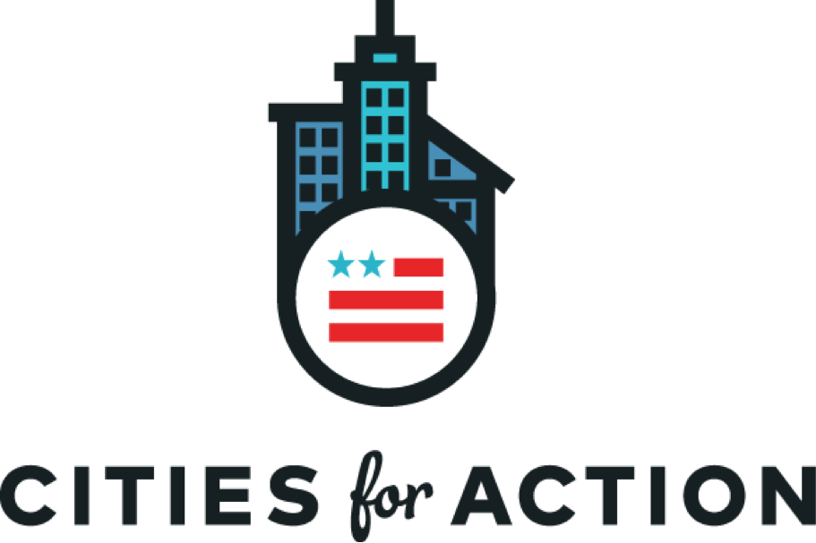

The Honorable Rex Tillerson
Secretary of State
U.S. Department of State
2201 C Street NW
Washington, DC 20520
The Honorable John Kelly
Secretary of Homeland Security
U.S. Department of Homeland Security
3801 Nebraska Avenue, NW
Washington, DC 20528

May 17, 2017

Dear Secretaries Kelly and Tillerson:

On behalf of the over 200,000 Haitian-born community members living in our cities, we urge you to extend the Temporary Protected Status (TPS) designation for Haiti before it expires on July 22, 2017. Doing so would benefit our cities by ensuring that Haitian immigrant families in our communities may remain together and that Haitian immigrants with TPS would be protected from having to return to a country where dangerous conditions persist.

As local leaders, we have an interest in ensuring the vibrancy of our economies and the health and safety of all our residents, including our immigrant residents. Immigrants make our communities stronger economically, social, and culturally. We promote these interests through Cities for Action, a coalition of over 150 mayors and county executives that advocates for policies to welcome and embrace our foreign-born residents.

Terminating TPS for the approximately 50,000 Haitians who currently have it would significantly impact local economies and communities. Our Haitian immigrant residents work, pay taxes, and contribute to our cities every day. They are ingrained in every aspect of our cities as they own small businesses, serve in our governments, and work in our hospitals and schools. A decision to terminate TPS would not only affect those who currently have Haitian TPS, but negatively impact their family members, employers, and communities as well.

Extending TPS would also protect our Haitian immigrant residents from returning to dangerous and unlivable conditions. Haiti first received TPS designation because of the devastating impacts of a 7.0 magnitude earthquake in 2010. With rebuilding efforts from the earthquake still incomplete, Hurricane Matthew struck the country in October of last year, undoing much of the recovery effort and causing immense loss of life. The country remains devastated, suffering from severe food shortages and a significant deterioration of living conditions.

Additionally, cholera remains rampant and deadly –it has killed over 10,000 people and sickened hundreds of thousands more since the earthquake. 2,000 new cholera cases were reported in just the period of February to mid-March of this year. TPS was designed specifically to protect residents of our communities during humanitarian emergencies— the extension of its designation for Haitians would be in the best interest of our cities and our country at large.

Local governments have a considerable interest in extending Haitian TPS, keeping immigrant families together, and preventing members of our communities from being forced to return to dangerous conditions. Therefore, we urge you to uphold our nation’s position as a humanitarian leader by continuing protections for Haitian immigrants and allowing them to remain temporarily within our country through an extension of TPS.

Sincerely,
Martin J. Walsh, Mayor of Boston, MA
E. Denise Simmons, Mayor of Cambridge, MA
Deborah Frank Feinen, Mayor of Champaign, IL
Rahm Emanuel, Mayor of Chicago, IL
Eric Garcetti, Mayor of Los Angeles, CA
Isiah Leggett, County Executive of Montgomery County, MD
Tomás Regalado, Mayor of Miami, FL
Ras Baraka, Mayor of Newark, NJ
Bill de Blasio, Mayor of New York City, NY
James F. Kenney, Mayor of Philadelphia, PA
Joseph Curtatone, Mayor of Somerville, MA
David Martin, Mayor of Stamford, CT
Stephanie Miner, Mayor of Syracuse, NY
Muriel Bowser, Mayor of Washington, D.C.

